TEST 1

1. Two streams merge to form a river. One stream has a width of $8.2 m$, depth of $3.4 m$, and current speed of $2.3 m/s$. The other stream is $6.8 m$ wide and $3.2 m$ deep, and flows at $2.6 m/s$. If the river has width $10.5 m$ and speed $2.9 m/s$, what is its depth?
2. About one-third of the body of a person floating in the Dead Sea will be above the waterline. Assuming that the human body density is $0.98 g/cm^{3}$, find the density of the water in the Dead Sea. (Why is it so much greater than $1.0 g/cm^{3}$?).
3. A steel rod is $3 cm$ in diameter at $25°C$. A brass ring has an interior diameter of 2.992 cm at $25°C$. At what common temperature will the ring just slide onto the rod? $(∝_{steel}=11$ x ${10}^{-6} ,∝_{brass}=19$ x ${10}^{-6} )$.
4. 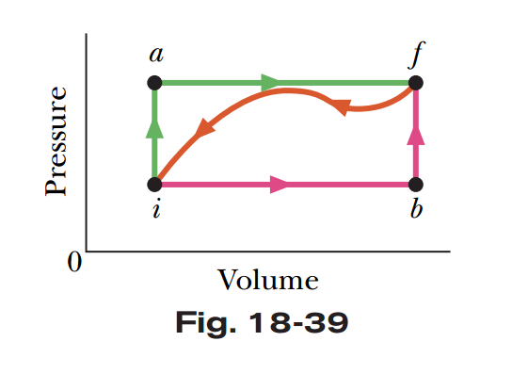In the closed room, a young researcher does the experiment that fully submerged a copper spoon at $100 °C$, $20g$ of mass, into a glass of water. Assume that room temperature is $20 °C$ and no heat release to air. It is know that glass is $50g$ of mass and containing $200ml$ water. What is the final temperature of the spoon? $(c_{copper}=386\frac{J}{kgK} , c_{glass}=840\frac{J}{kgK} ,c_{water}=4198\frac{J}{kgK}, ρ_{water}={1g}/{ml})$.

(Hint: temperature of water and glass equal to room temperature)

1. When a system is taken from state $i$ to state $f$ along path $iaf$ in Fig. 18-39, $Q= 50 cal$ and $W= 20 cal$. Along path $ibf$, $Q= 36 cal$. (a) What is $W$ along path $ibf$? (b) If $W=-13 cal$ for the return path $fi$, what is $Q$ for this path? (c) If ${E }_{int,i}=10 cal$, what is ${E }_{int,f}$? If ${E }_{int,b}=22 cal$, what is $Q$ for (d) path $ib$ and (e) path $bf$?